# EX.NO:9 DATE:11.09.2024

**ANALYZE DIFFERENT TYPES OF SERVERS USING WEBALIZER**

# AIM:

To analyze the different types of web logs using Webalizer tool.

# PROCEDURE:

Step 1: Download Apache web server using- dnf install httpd Step 2: Configure SELINUX to permissive mode

(open /etc/sysconfig/selinux Put SELINUX=permissive) Step 3: Start Apache web server using- systemctl start httpd.service

Step 4: Create a directory for webalizer using - mkdir /var/www/html/webalizer Step 5: Install webalizer using - dnf install webalizer

Step 6: Copy files from /var/www/usage to /var/www/html Step 7: Open /etc/webalizer.conf file and add the following-

LogFile /var/log/httpd/access_log LogType clf

Hostname localhost

Output Dir /var/www/html/webalizer Step 8: Save it and then run webalizer

Step 9: Open in web browser <http://localhost/webalizer>

**Webalizer**

#Instructions to install, configure and run Webalizer on Fedora #Enter the root password after typing su

Step 1:Download Apache web server using- dnf install httpd dnf install httpd

Step 2:Configure SELINUX to permissive mode

(open /etc/sysconfig/selinux Put SELINUX=permissive) vi

/etc/sysconfig/selinux

Put SELINUX=permissive instead of enforcing

Step 3: Start Apache web server using- systemctl start httpd.service systemctl enable httpd.service systemctl start httpd.service

Step 4: Create a directory for webalizer using - mkdir /var/www/html/webalizer mkdir

/var/www/html/webalizer

Step 5: Install webalizer using - dnf install webalizer dnf install webalizer

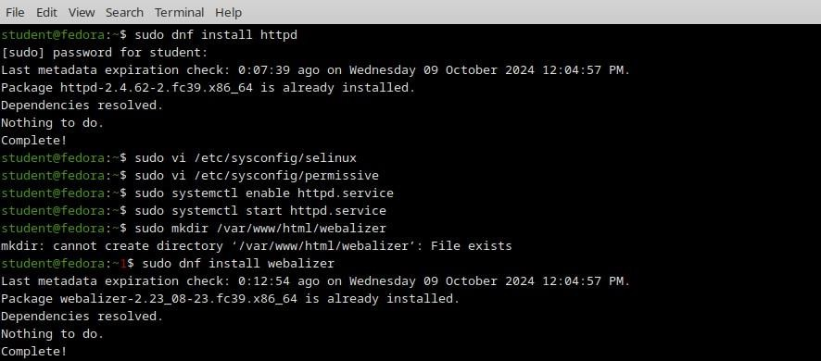

Step 6: Copy files from /var/www/usage to /var/www/html cp -r /var/www/usage /var/www/html



Step 7: Open /etc/webalizer.conf file and add the following- vi /etc/webalizer.conf

#add the following lines

LogFile /var/log/httpd/access_log #This is enabled in newer versions of fedora

LogType clf

Hostname localhost #For this one you can remove comment denoted by '#' OutputDir /var/www/html/webalizer

Step 8: Save it and then run webalizer



Step 9: Open in web browser <http://localhost/webalizer> Open in browser <http://localhost/webalizer>

Click Oct.2023 link to get the report for this month

# OUTPUT:

**Monthly statistics**

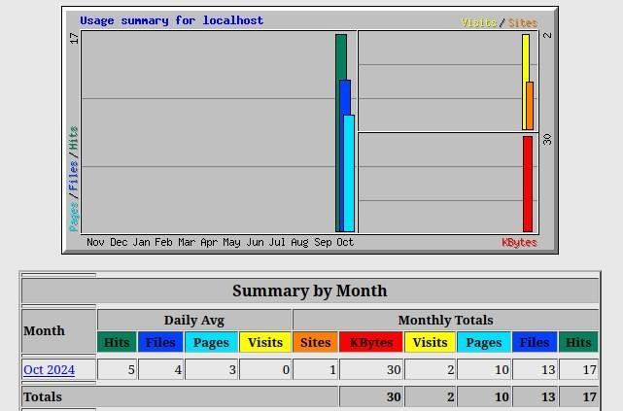

# Hosts

**Hourly usage**

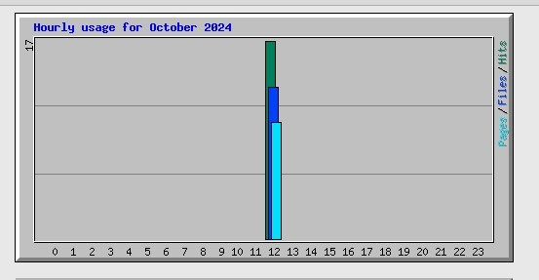

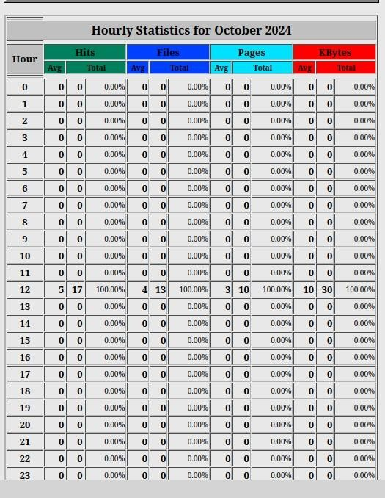

# Result:

Thus we successfully analyze the different types of web logs using Webalizer tool.